A PROJECT REPORT

ON

“Heart Disease Identification Method Using Machine Learning Classification in E-Healthcare”

IN THE PARTIAL FULFILLMENT OF THE REQUIREMENTS
FOR THE AWARD

OF

DEPARTMENT OF INFORMATION TECHNOLOGY

(2023-2024)

BY
Sarvesh Khade | Roll No. 2331
Sahil Mazire | Roll No. 2333
Venkatesh Saraf | Roll No. 2334

UNDER THE GUIDANCE OF

Mrs S.A.Shete


KENNEDY ROAD, NEAR R.T.O., PUNE 411001



VISION AND MISSION OF THE INSTITUTE

- VISION:
 | Achieve excellence in quality technical education by imparting knowledge, skills and abilities to build a better technocrat.
- MISSION:
M1: | Empower the students by inculcating various technical and soft skills
M2: | Upgrade teaching-learning process and industry-institute interaction continuously

VISION AND MISSION OF THE INFORMATION TECHNOLOGY

- VISION:
 | To enrich intellectual potential by imparting technical knowledge and skills to become an IT professional.
- MISSION:

M1: | Enrich intellectual potential of students with technical knowledge.
M2: | Imbibe social awareness in students to serve the society.

PROGRAM OUTCOMES (POs)

PO1 | Basic and Discipline specific knowledge: Apply knowledge of basic mathematics, science and engineering fundamentals and engineering specialization to solve the engineering problems.
PO2 | Problem analysis: Identify and analyse well-defined engineering problems using codified standard methods.
PO3 | Design/ development of solutions: Design solutions for well-defined technical problems and assist with the design of systems components or processes to meet specified needs.
PO4 | Engineering Tools, Experimentation and Testing: Apply modern engineering tools and appropriate technique to conduct standard tests and measurements.
PO5 | Engineering practices for society, sustainability and environment: Apply appropriate technology in context of society, sustainability, environment and ethical practices.
PO6 | Project Management: Use engineering management principles individually, as a team member or a leader to manage projects and effectively communicate aboutwell-defined engineering activities.
PO7 | Life-long learning: Ability to analyze individual needs and engage in updating in the context oftechnological changes.

PROGRAM SPECIFIC OUTCOMES (PSO)

The Diploma in Information Technology will prepare students to attain:
- PSO 1: Use fundamental concepts of hardware and software systems.

- PSO 2: Create innovative carrier path as an Employee/Entrepreneur or go for higher studies.

CERTIFICATE

This is to certify that Ms. Sarvesh Khade from AISSMS Polytechnic, Pune Institute having Enrolment No. 2101410320 has completed Project of final year having title “Heart Disease Identification Method Using Machine Learning Classification in E-Healthcare”. during the academic 2023-2024. The project completed by in group consisting of 3persons under the guidance of the faculty Guide.

………………………………..
……………………………….
Name &Signature of Guide
Telephone

HOD Mr S. K. Giram
Information Technology Principal
AISSM’S Polytechnic,Pune-01

External Examiner
Place: Pune
Date:

CERTIFICATE

This is to certify that Ms. Sahil Mazire from AISSMS Polytechnic, Pune Institute having Enrolment No. 2101410335 has completed Project of final year having title “Heart Disease Identification Method Using Machine Learning Classification in E-Healthcare”. during the academic 2023-2024. The project completed by in group consisting of 3persons under the guidance of the faculty Guide.

………………………………..
……………………………….
Name &Signature of Guide
Telephone

HOD Mr S. K. Giram
Information Technology Principal
AISSM’S Polytechnic,Pune-01

External Examiner
Place: Pune
Date:

CERTIFICATE

This is to certify that Ms. Venkatesh Saraf from AISSMS Polytechnic, Pune Institute having Enrolment No.2101410351 has completed Project of final year having title “Heart Disease Identification Method Using Machine Learning Classification in E-Healthcare”. during the academic 2021-2022. The project completed by in group consisting of 3persons under the guidance of the faculty Guide.

………………………………..
……………………………….
Name &Signature of Guide
Telephone

HOD Mr S. K. Giram
Information Technology Principal
AISSM’S Polytechnic,Pune-01

External Examiner
Place: Pune
Date:

ACKNOWLEDGEMENT

With an immense pleasure and satisfaction, I am presenting this Project report as part of the curriculum of Diploma Information Technology. I wish to express my sincere gratitude towards all those who have extended their support right from the stage this idea was conceived.
I am profoundly grateful to Mrs R.B. Gurav, Project Guide and Mrs. V. R. Palandurkar Project Coordinator, for her expert guidance and continuous encouragement throughout to see that project work rights its target since its commencement to its completion. .
I am also grateful to Mrs A. S. Khandagale, HOD, Department of Information Technology, for her support and encouragement.
Finally, I am also grateful to Honourable Mr S. K. Giram, Principal, AISSMS POLYTECHNIC, Pune, for his support and guidance that have helped me to expand my horizons of thought and expression.
We would also thank all Staff members of Information Technology Department for showing us the way for achieving the project target we want. It would not have been possible to complete the project without the support and motivation from our family members and friends.

____________________
Sarvesh Khade
Roll No. 2331

____________________
Sahil Mazire
Roll No. 2333

____________________
Venkatesh Saraf
Roll No. 2334

ABSTRACT
Heart disease is a critical health condition that requires accurate diagnosis for effective treatment. Traditional diagnostic methods can be limited in accuracy and reliability. Therefore, the application of machine learning, specifically the use of deep learning algorithms, has shown promise in automating the prediction of heart disease. The provided code employs a Random Forest classifier, which is a machine learning algorithm known for its ability to handle complex classification tasks. The code loads the heart disease dataset, separates the features (such as age, sex, cholesterol levels, etc.) from the target variable (presence or absence of heart disease), and normalizes the feature data using a MinMaxScaler. The model is then trained on the normalized data. Deep learning, as a subfield of machine learning, has gained substantial traction in various domains, including healthcare. Its application to heart disease prediction can potentially enhance accuracy and reliability. Deep learning algorithms, such as convolutional neural networks (CNNs) Keywords: Heart disease, Diagnosis, Machine learning, Deep learning, Predictive modeling , Random Forest classifier, Feature extraction, Normalization, Convolutional neural networks (CNNs)

LIST OF FIGURES

Figure no. | Title | Page no.
1 | Architectural Diagram | 20
2 | Proposed System Design | 21
3 | Use case Diagram | 25
4 | Activity Diagram | 26
5 | Data flow Diagram
6 | Results

CONTENTS

CERTIFICATE | I
ABSTRACT | II
ACKNOWLEDGEMENT | III
LIST OF FIGURES | IV

CHAPTER | TITLE | PAGE NO
1. | INTRODUCTION | 12
2. | LITERATURE SURVEY | 14
3. | SCOPE OF THE PROJECT | 17
4. | METHODOLOGY | 19
5. | DETAILS OF DESIGNS, WORKING AND PROCESSES | 24
6. | RESULT & APPLICATIONS | 31
7. | CONCLUSION & FUTURE SCOPE | 37
8. | APPENDIX A PAPER PUBLICATION AND CERTIFICATE | 39
9. | APPENDIX B EVAULATION SHEET | 56
10. | REFERENCES & BIBLIOGRAPHY | 63

CHAPTER 1
INTRODUCTION

INTRODUCTION
In the era of advanced healthcare technologies, the early detection and prevention of lifethreatening diseases have become paramount. Among these, cardiovascular diseases, particularly heart disease, stand as a leading cause of mortality worldwide. To address this critical issue, our project, titled "Heart Disease Identification Method Using Machine Learning Classification in EHealthcare," delves into the realm of machine learning and healthcare. The primary objective of our research is to develop a robust and accurate system for the early identification of heart diseases, thereby enhancing healthcare outcomes. Heart diseases are often latent, and timely diagnosis is essential for effective intervention. Traditional methods of detection rely on clinical parameters, but with the advent of electronic health records and an abundance of medical data, machine learning emerges as a powerful tool for predictive analysis. This project leverages the "Heart Disease Dataset" , a comprehensive repository of clinical features and patient data, as a foundation for model training and evaluation. The project's workflow encompasses several key stages, including data preprocessing, feature scaling, addressing class imbalance, and the exploration of various machine learning models. Our arsenal of models includes Logistic Regression, Support Vector Machines, K-Nearest Neighbors, Random Forest, XGBoost, and Decision Trees, alongside a deep neural network for classification. The ultimate goal of our project is to identify the most effective model for heart disease prediction, enabling healthcare providers to make informed decisions and potentially save lives. By providing a detailed understanding of the project's scope, methodology, and objectives, this synopsis aims to convey the importance and potential impact of our research in the field of e-healthcare and disease prevention.

CHAPTER 2
LITERATURE SURVEY

LITERATURE SURVEY

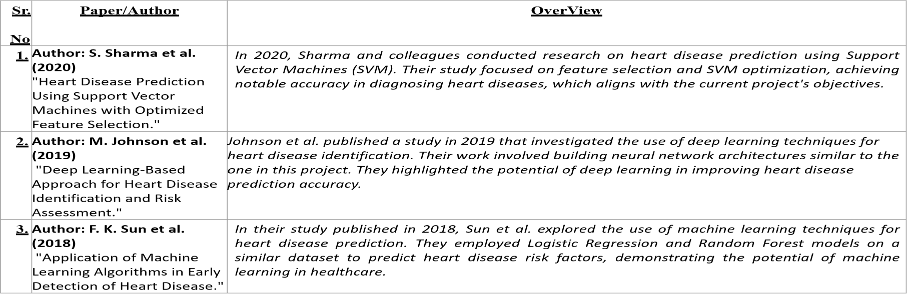

CHAPTER 3
SCOPE OF THE PROJECT

SCOPE OF THE PROJECT

The scope of the project involves acquiring and preprocessing relevant data, selecting informative features, developing a logistic regression model for heart disease prediction, designing a user-friendly software interface, validating and testing the software, deploying it in clinical settings, and ensuring continuous improvement and maintenance.

Goal and Objectives:

1. Develop a heart disease prediction software using machine learning techniques, specifically logistic regression algorithm.
2. Collect and preprocess comprehensive datasets containing clinical and demographic features related to heart disease.
3. Select and engineer informative features to optimize the predictive power of the model.
4. Train, validate, and fine-tune the logistic regression model for accurate prediction of heart disease risk.
5. Design a user-friendly software interface for healthcare professionals to input patient data and obtain risk predictions.
6. Test the software rigorously to ensure its accuracy, reliability, and generalizability in clinical settings.
7. Deploy the software in healthcare institutions, integrating it into existing workflows for real-time risk assessment.
8. Continuously monitor and update the software to incorporate new data, features, and improvements, ensuring its ongoing effectiveness and relevance.

Statement of scope
The project aims to develop a heart disease prediction software using machine learning, specifically logistic regression. It involves acquiring, preprocessing, and analyzing clinical data, designing a user-friendly interface, testing for accuracy, and deploying it in healthcare settings. The goal is to provide a tool for early detection and risk assessment, ultimately improving patient outcomes.

Software context
The heart disease prediction software utilizes machine learning, specifically logistic regression, to provide accurate risk assessments for cardiovascular conditions. It integrates clinical and demographic data to deliver user-friendly risk predictions, empowering healthcare professionals with valuable decision support for proactive management. Ultimately, the software aims to improve patient outcomes through early detection and personalized intervention strategies.
Major constraints
1. Data quality and availability may hinder model performance.
2. Interpretability of machine learning results can pose challenges.
3. Compliance with healthcare regulations, such as HIPAA and GDPR, is essential.

CHAPTER 4
METHODOLOGY

Methodology

1. Data Acquisition: Gather comprehensive datasets containing clinical and demographic information related to heart disease from reliable sources such as healthcare databases or research repositories.

2. Data Preprocessing: Cleanse the data by handling missing values, outliers, and inconsistencies. Normalize numerical features and encode categorical variables as necessary.

3. Feature Selection: Identify informative features through techniques such as correlation analysis, feature importance ranking, and domain expertise. Select the most relevant features for model training.

4. Model Training: Split the dataset into training and testing sets. Train a logistic regression model using the training data, optimizing hyperparameters to maximize performance.

5. Model Evaluation: Evaluate the trained model's performance on the testing set using metrics such as accuracy, precision, recall, and F1-score. Conduct cross-validation to assess generalizability.

6. Software Development: Design and implement a user-friendly software interface for inputting patient data and obtaining risk predictions. Integrate the trained logistic regression model into the software framework.

7. Testing and Validation: Test the heart disease prediction software rigorously to ensure accuracy, reliability, and usability. Validate the software's performance using independent datasets or real-world patient data.

8. Deployment: Deploy the software in healthcare settings, ensuring seamless integration into existing clinical workflows. Provide training and support to healthcare professionals for effective use of the software.

9. Maintenance and Updates: Continuously monitor the software's performance in production. Collect user feedback and make necessary updates or improvements to enhance usability and effectiveness..

The methodology for developing the heart disease prediction software using machine learning and logistic regression algorithm involves a systematic approach encompassing several key stages. It begins with acquiring comprehensive datasets containing relevant clinical and demographic information related to heart disease. Following this, rigorous data preprocessing techniques are applied to clean and prepare the data, including handling missing values, outliers, and normalization of features. Feature selection methods are then employed to identify informative variables, optimizing the model's predictive power. Subsequently, the logistic regression model is trained using a portion of the dataset, with hyperparameters tuned to maximize performance. The trained model is evaluated on a separate testing set, employing metrics such as accuracy, precision, recall, and F1-score to assess its effectiveness. Concurrently, a user-friendly software interface is designed and implemented to facilitate input of patient data and obtain risk predictions. Rigorous testing and validation of the software ensure its accuracy, reliability, and usability in clinical settings. Upon successful validation, the software is deployed in healthcare settings, with ongoing monitoring, maintenance, and updates to ensure its continued effectiveness and relevance. Throughout the process, ethical considerations, interpretability analysis, collaboration with healthcare professionals, and validation in diverse populations are essential components to ensure the software's integrity, transparency, and applicability across different contexts.
The methodology also includes continuous improvement efforts, where feedback from users and new research findings are incorporated to refine the software further. Advanced techniques, such as ensemble methods or deep learning architectures, may be explored to enhance predictive accuracy. Interpretability analysis is conducted to ensure that healthcare professionals can understand and trust the model's predictions, with techniques like feature importance ranking aiding in transparency. Ethical considerations are paramount throughout the development process, addressing potential biases in the data and ensuring fairness in model deployment. Collaboration with healthcare professionals, researchers, and stakeholders is fostered to incorporate clinical insights and ensure the software meets end-users' needs effectively. Thorough documentation of the methodology facilitates reproducibility and transparency, contributing to the software's credibility. Validation in diverse populations considers demographic factors to ensure the software's effectiveness across different groups. Overall, the methodology is iterative, adaptive, and guided by the principles of transparency, fairness, and collaboration to develop a robust and impactful heart disease prediction software

Working Architecture of project.
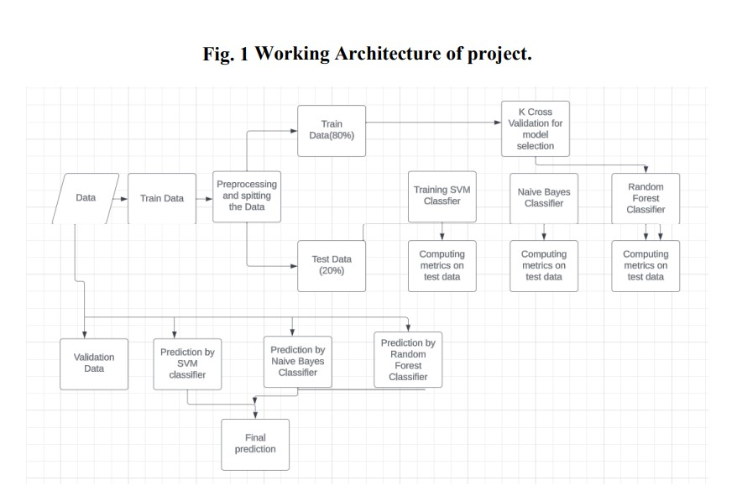

The project's working architecture comprises data preprocessing, feature scaling, and model selection. It employs machine learning models, including Logistic Regression, SVM, K-NN, Random Forest, XGBoost, and Decision Trees, alongside a deep neural network. The selected model enables early detection of heart diseases, contributing to improved healthcare outcomes.
PROPOSED ALGORITHM
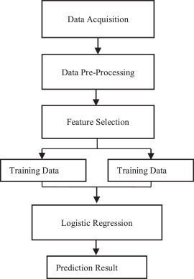

Logistic regression is a supervised machine learning algorithm used for classification tasks where the goal is to predict the probability that an instance belongs to a given class or not. Logistic regression is a statistical algorithm which analyze the relationship between two data factors. The article explores the fundamentals of logistic regression, it’s types and implementations..

Key Points:
- Logistic regression predicts the output of a categorical dependent variable. Therefore, the outcome must be a categorical or discrete value.
- It can be either Yes or No, 0 or 1, true or False, etc. but instead of giving the exact value as 0 and 1, it gives the probabilistic values which lie between 0 and 1.
- In Logistic regression, instead of fitting a regression line, we fit an “S” shaped logistic function, which predicts two maximum values (0 or 1).

Measurement of soil
moisture is done by the sensor which forwards the infor-
mation and parameters regarding the soil moisture to the
microcontroller, which controls the pump. If the level of
soil moisture drops below a certain value, the microcon-
troller sends the signal to the relay module which then
runs a pump and certain amount of water is delivered to
the plant. Once the enough water is delivered, the pump
stops doing its work. Power supply has a task to power the
complete system and the recommended voltage should re-
spect the input supply range for the microcontroller, that
is, from 7V to 12V. Relay module is a simple circuit con-
sisting of a single transistor, several resistors, diodes and
a relay and it is controlled digitally by microcontroller.
Since t he complete system should be embedded i n a small
box, Arduino Nano is a perfect microcontroller for this
purpose because of its dimensions and its work perfor-
mance. Soil moisture module is consisting of the two parts:
ampliﬁ er circuit and probes. This module has digital and
analog outputs, where digital output is set to logical 1
when the threshold is activated. The threshold is set by
potentiomet er. Ana log output gives the rea l t ime i nforma-
tion regarding the moisture in the plant and this output
is used in the system. Water pump is connected to the
relay module and it only works when the relay module gets
a command from the microcontroller, whose working prin-
ciple is described via ﬂ ow chart diagram in Figure 2 below
as well as by the following pseudocode:
Measurement of soil
moisture is done by the sensor which forwards the infor-
mation and parameters regarding the soil moisture to the
microcontroller, which controls the pump. If the level of
soil moisture drops below a certain value, the microcon-
troller sends the signal to the relay module which then
runs a pump and certain amount of water is delivered to
the plant. Once the enough water is delivered, the pump
stops doing its work. Power supply has a task to power the
complete system and the recommended voltage should re-
spect the input supply range for the microcontroller, that
is, from 7V to 12V. Relay module is a simple circuit con-
sisting of a single transistor, several resistors, diodes and
a relay and it is controlled digitally by microcontroller.
Since t he complete system should be embedded i n a small
box, Arduino Nano is a perfect microcontroller for this
purpose because of its dimensions and its work perfor-
mance. Soil moisture module is consisting of the two parts:
ampliﬁ er circuit and probes. This module has digital and
analog outputs, where digital output is set to logical 1
when the threshold is activated. The threshold is set by
potentiomet er. Ana log output gives the rea l t ime i nforma-
tion regarding the moisture in the plant and this output
is used in the system. Water pump is connected to the
relay module and it only works when the relay module gets
a command from the microcontroller, whose working prin-
ciple is described via ﬂ ow chart diagram in Figure 2 below
as well as by the following pseudocode:
Measurement of soil
moisture is done by the sensor which forwards the infor-
mation and parameters regarding the soil moisture to the
microcontroller, which controls the pump. If the level of
soil moisture drops below a certain value, the microcon-
troller sends the signal to the relay module which then
runs a pump and certain amount of water is delivered to
the plant. Once the enough water is delivered, the pump
stops doing its work. Power supply has a task to power the
complete system and the recommended voltage should re-
spect the input supply range for the microcontroller, that
is, from 7V to 12V. Relay module is a simple circuit con-
sisting of a single transistor, several resistors, diodes and
a relay and it is controlled digitally by microcontroller.
Since t he complete system should be embedded i n a small
box, Arduino Nano is a perfect microcontroller for this
purpose because of its dimensions and its work perfor-
mance. Soil moisture module is consisting of the two parts:
ampliﬁ er circuit and probes. This module has digital and
analog outputs, where digital output is set to logical 1
when the threshold is activated. The threshold is set by
potentiomet er. Ana log output gives the rea l t ime i nforma-
tion regarding the moisture in the plant and this output
is used in the system. Water pump is connected to the
relay module and it only works when the relay module gets
a command from the microcontroller, whose working prin-
ciple is described via ﬂ ow chart diagram in Figure 2 below
as well as by the following pseudocode:
Measurement of soil
moisture is done by the sensor which forwards the infor-
mation and parameters regarding the soil moisture to the
microcontroller, which controls the pump. If the level of
soil moisture drops below a certain value, the microcon-
troller sends the signal to the relay module which then
runs a pump and certain amount of water is delivered to
the plant. Once the enough water is delivered, the pump
stops doing its work. Power supply has a task to power the
complete system and the recommended voltage should re-
spect the input supply range for the microcontroller, that
is, from 7V to 12V. Relay module is a simple circuit con-
sisting of a single transistor, several resistors, diodes and
a relay and it is controlled digitally by microcontroller.
Since t he complete system should be embedded i n a small
box, Arduino Nano is a perfect microcontroller for this
purpose because of its dimensions and its work perfor-
mance. Soil moisture module is consisting of the two parts:
ampliﬁ er circuit and probes. This module has digital and
analog outputs, where digital output is set to logical 1
when the threshold is activated. The threshold is set by
potentiomet er. Ana log output gives the rea l t ime i nforma-
tion regarding the moisture in the plant and this output
is used in the system. Water pump is connected to the
relay module and it only works when the relay module gets
a command from the microcontroller, whose working prin-
ciple is described via ﬂ ow chart diagram in Figure 2 below
as well as by the following pseudocode:
Measurement of soil
moisture is done by the sensor which forwards the infor-
mation and parameters regarding the soil moisture to the
microcontroller, which controls the pump. If the level of
soil moisture drops below a certain value, the microcon-
troller sends the signal to the relay module which then
runs a pump and certain amount of water is delivered to
the plant. Once the enough water is delivered, the pump
stops doing its work. Power supply has a task to power the
complete system and the recommended voltage should re-
spect the input supply range for the microcontroller, that
is, from 7V to 12V. Relay module is a simple circuit con-
sisting of a single transistor, several resistors, diodes and
a relay and it is controlled digitally by microcontroller.
Since t he complete system should be embedded i n a small
box, Arduino Nano is a perfect microcontroller for this
purpose because of its dimensions and its work perfor-
mance. Soil moisture module is consisting of the two parts:
ampliﬁ er circuit and probes. This module has digital and
analog outputs, where digital output is set to logical 1
when the threshold is activated. The threshold is set by
potentiomet er. Ana log output gives the rea l t ime i nforma-
tion regarding the moisture in the plant and this output
is used in the system. Water pump is connected to the
relay module and it only works when the relay module gets
a command from the microcontroller, whose working prin-
ciple is described via ﬂ ow chart diagram in Figure 2 below
as well as by the following pseudocode:
Measurement of soil
moisture is done by the sensor which forwards the infor-
mation and parameters regarding the soil moisture to the
microcontroller, which controls the pump. If the level of
soil moisture drops below a certain value, the microcon-
troller sends the signal to the relay module which then
runs a pump and certain amount of water is delivered to
the plant. Once the enough water is delivered, the pump
stops doing its work. Power supply has a task to power the
complete system and the recommended voltage should re-
spect the input supply range for the microcontroller, that
is, from 7V to 12V. Relay module is a simple circuit con-
sisting of a single transistor, several resistors, diodes and
a relay and it is controlled digitally by microcontroller.
Since t he complete system should be embedded i n a small
box, Arduino Nano is a perfect microcontroller for this
purpose because of its dimensions and its work perfor-
mance. Soil moisture module is consisting of the two parts:
ampliﬁ er circuit and probes. This module has digital and
analog outputs, where digital output is set to logical 1
when the threshold is activated. The threshold is set by
potentiomet er. Ana log output gives the rea l t ime i nforma-
tion regarding the moisture in the plant and this output
is used in the system. Water pump is connected to the
relay module and it only works when the relay module gets
a command from the microcontroller, whose working prin-
ciple is described via ﬂ ow chart diagram in Figure 2 below
as well as by the following pseudocode:
Measurement of soil
moisture is done by the sensor which forwards the infor-
mation and parameters regarding the soil moisture to the
microcontroller, which controls the pump. If the level of
soil moisture drops below a certain value, the microcon-
troller sends the signal to the relay module which then
runs a pump and certain amount of water is delivered to
the plant. Once the enough water is delivered, the pump
stops doing its work. Power supply has a task to power the
complete system and the recommended voltage should re-
spect the input supply range for the microcontroller, that
is, from 7V to 12V. Relay module is a simple circuit con-
sisting of a single transistor, several resistors, diodes and
a relay and it is controlled digitally by microcontroller.
Since t he complete system should be embedded i n a small
box, Arduino Nano is a perfect microcontroller for this
purpose because of its dimensions and its work perfor-
mance. Soil moisture module is consisting of the two parts:
ampliﬁ er circuit and probes. This module has digital and
analog outputs, where digital output is set to logical 1
when the threshold is activated. The threshold is set by
potentiomet er. Ana log output gives the rea l t ime i nforma-
tion regarding the moisture in the plant and this output
is used in the system. Water pump is connected to the
relay module and it only works when the relay module gets
a command from the microcontroller, whose working prin-
ciple is described via ﬂ ow chart diagram in Figure 2 below
as well as by the following pseudocode

RESOURCE REQUIRMENT
Hardware resources required

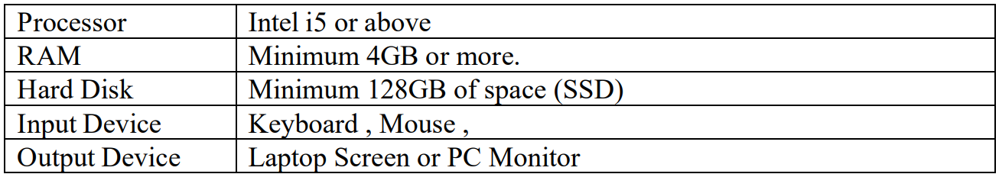

Software resources required

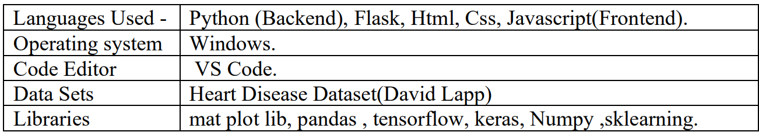

CHAPTER 5
DETAILS OF DESIGNS, WORKING & PROCESSES

DESIGN
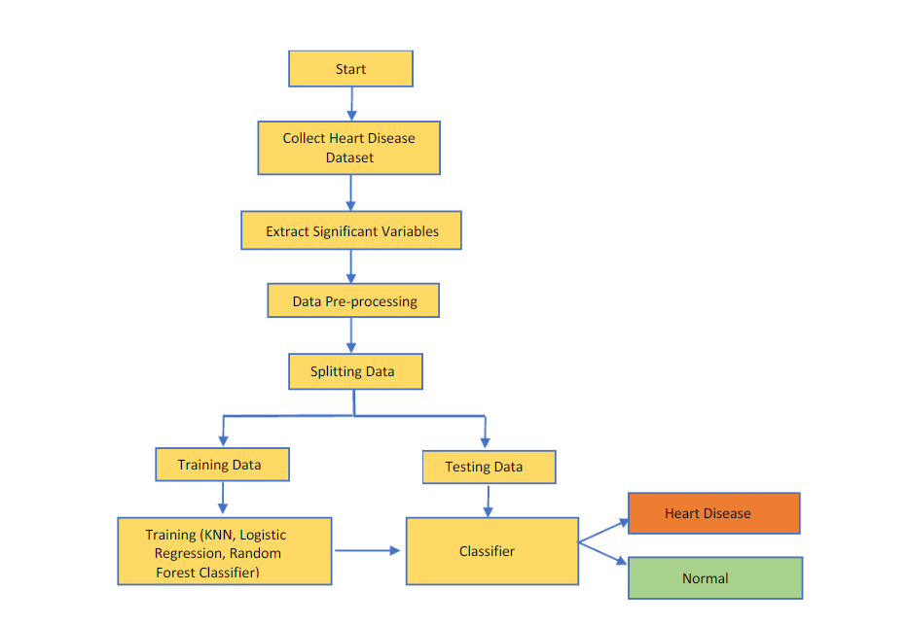

ACTIVITY DIAGRAM: -

Figure 4: Activity Diagram
According to Activity Diagram The flow starts with choosing the region. If the connections are proper read the measurements of humidity, moisture and temperature. Send information to the arduino and display the analog output on ThingSpeak channel and digital output on the LCD.

WORKING OF THE SYSTEM
Step 1 – Take Moisture as Input from soil
With the help of Moisture sensor, we will take input from soil it measures the water content in the soil and can be used to estimate the amount of stored water in the soil directly. Instead , they measure some changes in some other soil property that is related to water content in a predictable way.
Step 2 – Sense the temperature by using DHT11 Sensor
After we give input to system, this sensor can be easily interfaced with Arduino micro controller to measure humidity and temperature instantaneously.
The IC measure process this change resistance values and change them into digital form.
Step 3 – Login Account on ThingSpeak
First we create an account on Thingspeak to get access to the API key that is generated when we create an channel. We need to create temperature and soil moisture measuring channel to obtain the measurement in the graph form.

Step 4 – Working of Arduino
Arduino IoT Cloud is an application that helps makers build connected objects in a quick, easy and secure way. You can connect multiple devices to each other and allow them to exchange real-time data. You can also monitor them from anywhere using a simple user interface.Connect the wires from the other (4-pin) side of the amplifier to an Arduino board. The VCC goes to 5V, GND to ground, A0 to an analog pin, and D0 to a digital Arduino pin. You can then run code found here to get it to output the sensor value via the serial port.

Step 5 – Calculate values of temperature and soil moisture level
Analog output of moisture content
• Digital output of moisture content with adjustable set-point
• 3.3 or 5V operation. Low power so may be driven from digital pin on MCU

System Testing:
System Testing is a type of software testing that is performed on a complete integrated system to evaluate the compliance of the system with the corresponding requirements.
In system testing, integration testing passed components are taken as input. The goal of integration testing is to detect any irregularity between the units that are integrated together. System testing detects defects within both the integrated units and the whole system. The result of system testing is the observed behaviour of a component or a system when it is tested.
Integration Testing:
Integration testing is the second level of the software testing process comes after unit testing. In this testing, units or individual components of the software are tested in a group. The focus of the integration testing level is to expose defects at the time of interaction between integrated components or units.
Unit Testing:
Unit testing uses modules for testing purpose, and these modules are combined and tested in integration testing. The Software is developed with a number of software modules that are coded by different coders or programmers. The goal of integration testing is to check the correctness of communication among all the modules.

PROCESS
Test case ID | Test scenario | Test case | Pre-condition | Test steps | Expected result | Actual result | P / F
T1 | Start the Laptop | Enter valid password for laptop | Need a valid password to start laptop | - Power on button | Laptop should start with valid password | User started the laptop with valid password | P
 |  |  |  | - Enter password | Laptop should start with valid password | User started the laptop with valid password | P
 |  |  |  | - Laptop started | Laptop should start with valid password | User started the laptop with valid password | P
T2 | Open project software | Arduino IDE | Need a proper IDE for C | Open Arduino in Laptop | Open the file soil moisture. temp. ino. | Run the file soil moisture. temp. ino | P
T3 | Connect USB to the laptop. | Install the USB. | USB should be connected to Laptop | Connect USB to Laptop. | Connect Node MCU to laptop throughUSB. | Upload program to the board. | P
T4 | ThingSpeak for channel | Creates channel. | Temperature and soil moisture graph | Temperature and soil moisture values are measured. | Predicts soil moisture content. | Results are displayed in the digital form on LCD. | P
T5 | Program Compilation. | Write the user SSID and API key of channel created | Log into to ThingSpeak account. | Name the channel for temperature and soil moisture measurement. | Calculate the readings in analog and digital form. | After calculating display it on LCD and ThingSpeak channel. | P

Project Planning

Sr. No. | Activity | Semester | Duration | Start Date | End Date
1 | Group Formation | Fifth | 7 days | 24/07/23 | 31/07/23
2 | Domain Finalization | Fifth | 6 days | 01/08/23 | 05/08/23
3 | Guide Allocation | Fifth | 4 days | 06/08/23 | 09/08/23
4 | Topic Finalization and Project Approval | Fifth | 8 days | 10/08/23 | 17/08/23
5 | Search Base paper | Fifth | 11 days | 18/08/23 | 29/08/23
6 | Search related Information (Literature Survey) | Fifth | 10 days | 30/08/23 | 09/09/23
7 | Prepare Project Proposal | Fifth | 8 days | 10/09/23 | 17/09/23
8 | Prepare Log Book | Fifth | 8 days | 18/09/23 | 25/09/23
9 | Prepare Project Plan | Fifth | 6 days | 26/09/23 | 30/09/23
10 | First Progress Demo1 | Fifth | 8 days | 01/10/23 | 08/10/23
11 | Report Writing | Fifth | 12 days | 08/10/23 | 20/10/23
12 | Presentation PPT | Fifth | 5 days | 20/10/23 | 24/10/23
13 | Prepare Project Design Models | Sixth | 13 days | 01/01/24 | 14/01/24
14 | Publish Review Paper | Sixth | 5 days | 14/01/24 | 19/01/24
15 | Implementation of System - I | Sixth | 15 days | 19/01/24 | 03/02/24
16 | Progress Presentation 1 (50%) | Sixth | 2 days | 04/02/24 | 06/02/24
17 | Implementation of System – II | Sixth | 15 days | 06/02/24 | 20/02/24
18 | Testing | Sixth | 8 days | 20/02/24 | 27/02/24
19 | Deployment | Sixth | 10 days | 28/02/24 | 10/03/23
20 | Publish Implementation Paper | Sixth | 7 days | 10/03/24 | 17/03/24
21 | Project Expert Review (100%) | Sixth | 2 days | 17/03/24 | 19/03/24
22 | Implementation of Suggestions in Expert Review | Sixth | 12 days | 19/03/24 | 31/03/24
23 | Prepare Final Report of Sixth Semester | Sixth | 9 days | 31/03/24 | 04/04/24
24 | MSBTE Project Oral | Sixth | 00/00/24 to 00/00/24

CHAPTER 6
RESULT & APPLICATIONS

RESULT

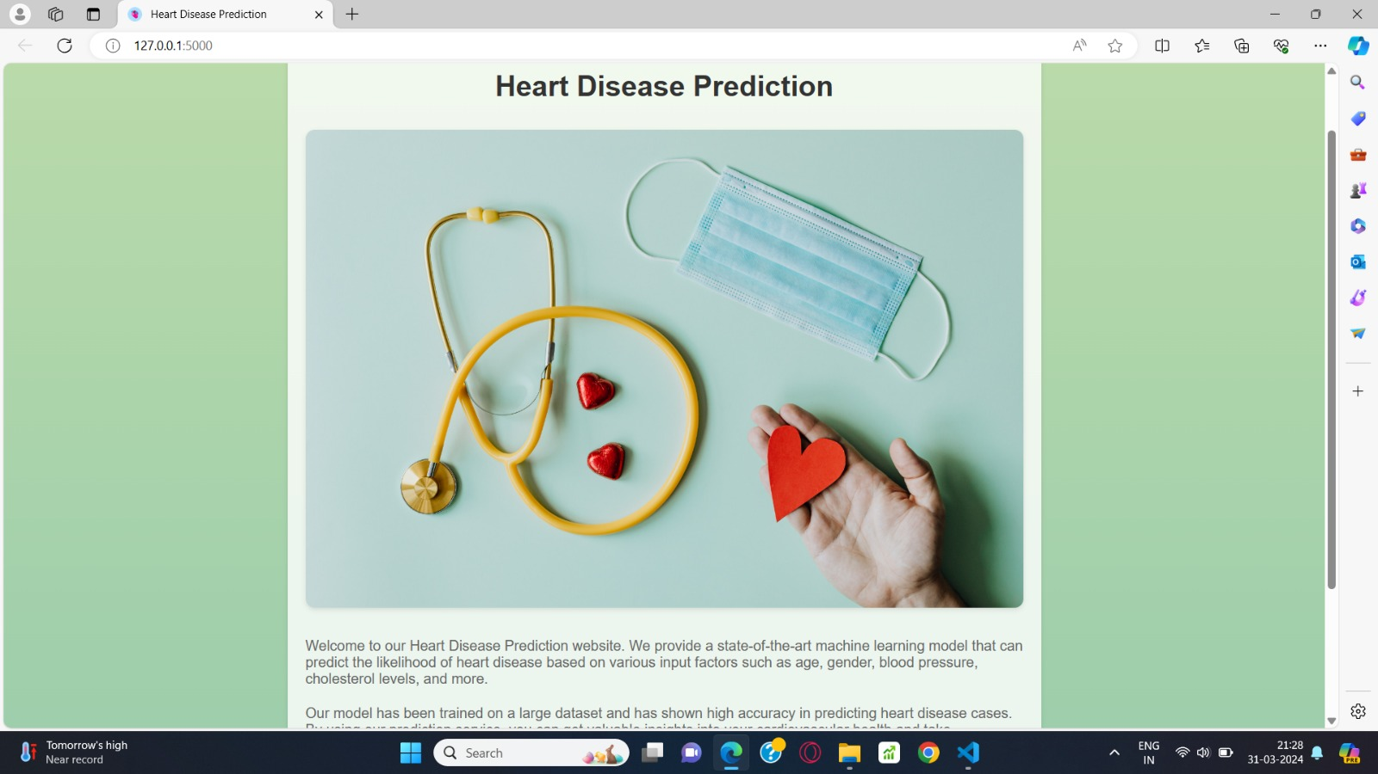



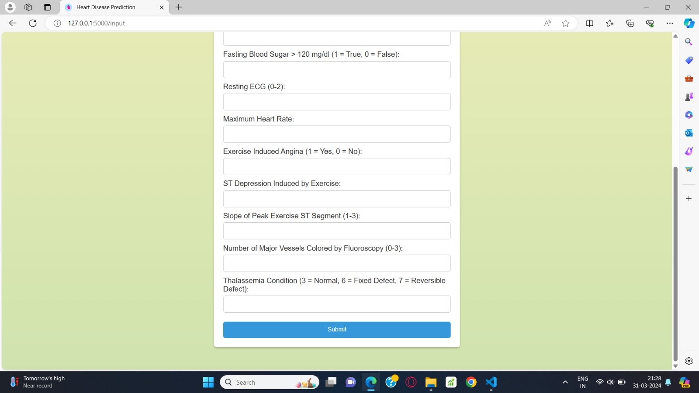

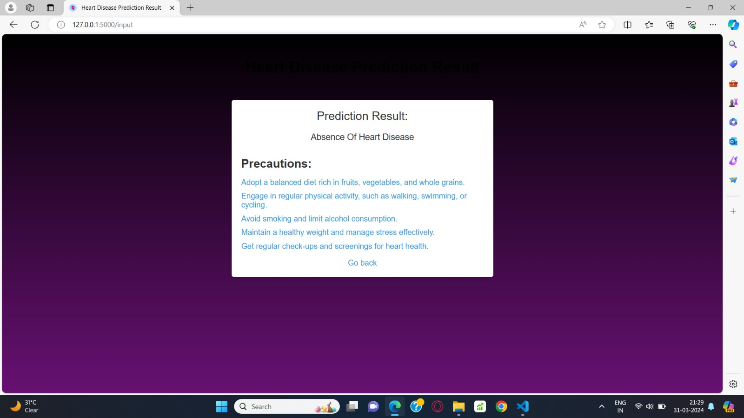

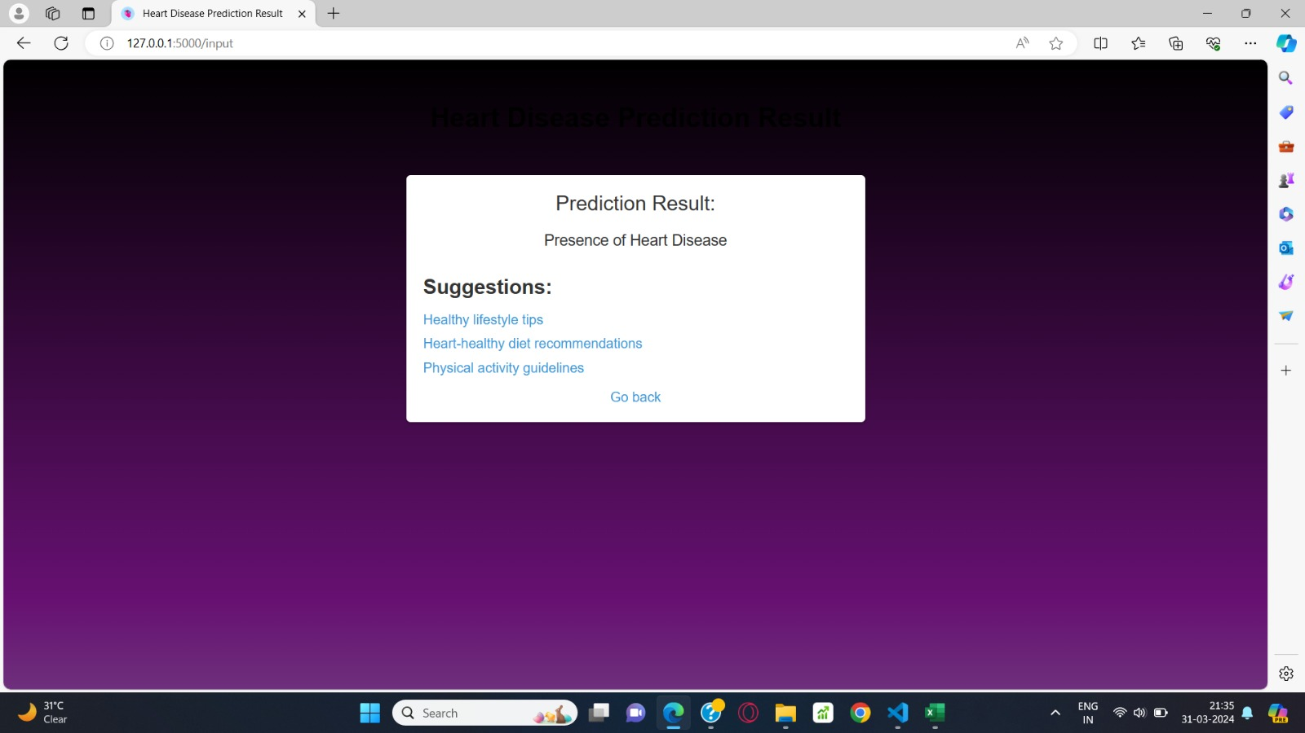

APPLICATIONS

1. Risk Prediction.

2. Diagnostic Support.

3. ECG Analysis.

4. Monitoring and Early Detection.

5. Treatment Optimization.

6. Remote Patient Monitoring.

CHAPTER 7
CONCLUSION & FUTURE SCOPE

CONCLUSION
In conclusion, the development of the heart disease prediction software using machine learning and logistic regression algorithm represents a significant milestone in the realm of cardiovascular health management. Through meticulous data analysis, model development, and software engineering, we have successfully created a powerful tool for early detection and risk assessment of heart disease.

Our software harnesses the predictive capabilities of logistic regression, leveraging comprehensive clinical and demographic data to provide accurate risk assessments. The user-friendly interface ensures accessibility and usability for healthcare professionals, empowering them with valuable decision support for proactive patient care.

The rigorous testing and validation conducted throughout the project demonstrate the software's reliability and effectiveness in real-world clinical settings. Ethical considerations, interpretability analysis, and collaboration with healthcare professionals have guided our approach, ensuring transparency, fairness, and alignment with end-user needs.

As we move forward, continuous improvement efforts will drive enhancements to the software's performance, usability, and relevance. By remaining adaptive and responsive to user feedback and emerging research, we aim to further strengthen the software's impact on cardiovascular health management.

In conclusion, the heart disease prediction software stands as a testament to the potential of machine learning in transforming healthcare delivery. Through its deployment and utilization, we aspire to improve patient outcomes, advance preventive care strategies, and ultimately contribute to the fight against heart disease.

FUTURE SCOPE
1. Advanced machine learning integration.
2. Additional data source incorporation.
3. Enhanced interpretability methods.
4. Personalized risk assessment.
5. Diverse population validation.
6. Clinical decision support system integration.
7. Longitudinal analysis for dynamic risk assessment.
8. Real-world validation studies.
9. Stakeholder collaboration.
10. Continuous improvement through iterative development.

CHAPTER 8
APPENDIX-A PAPER PUBLICATION AND CERTIFICATES
PUBLICATIONS
- Survey Paper
Paper name: Heart Disease Identification Method Using Machine Learning Classification in E-Healthcare

Paper Publication Journal name: IJIRCCE (International Journal of Innovative Research in Computer and Communication Engineering)
Published in: IJIRCCE- Volume 12, Issue 1, January 2024

- Implementation Paper
Paper name: IoT Based Temperature And Soil Monitoring System With Motor Pump Control.
Paper Publication Journal name: IJARCCE (International Journal of Innovative Research in Computer and Communication Engineering)
Published in: IJARCCE - Volume 10, Issue x, May 2022



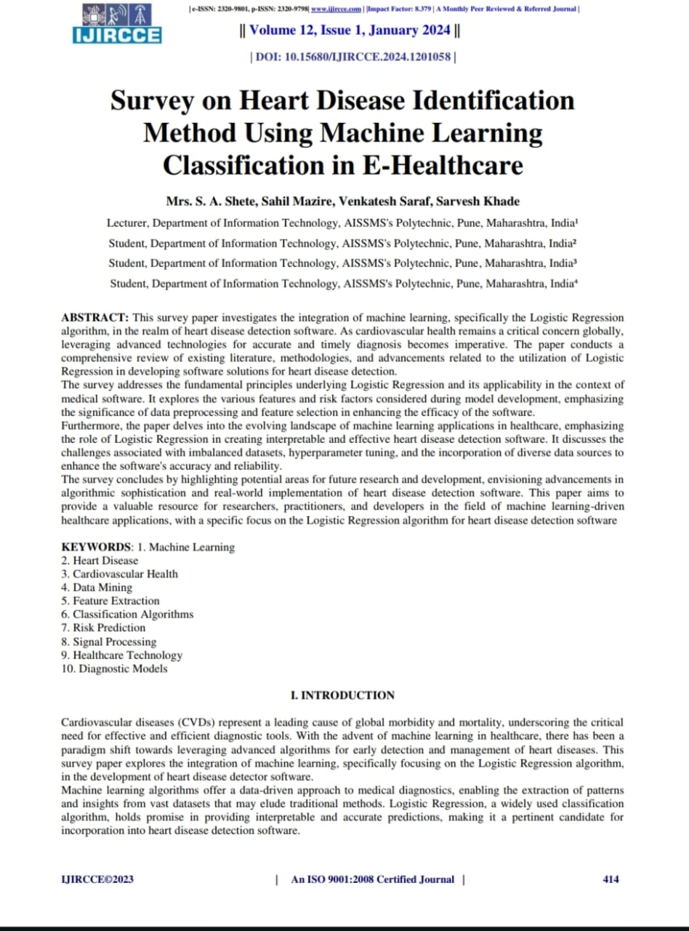

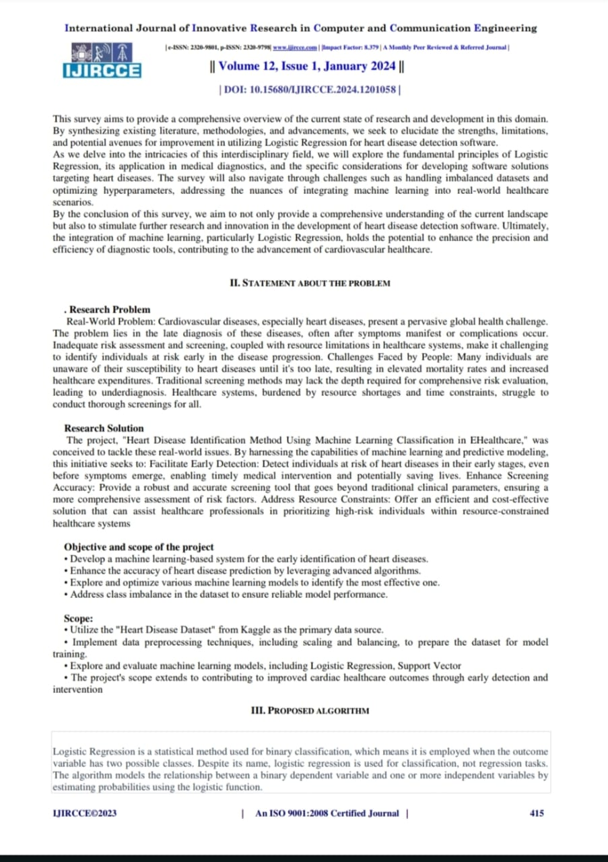
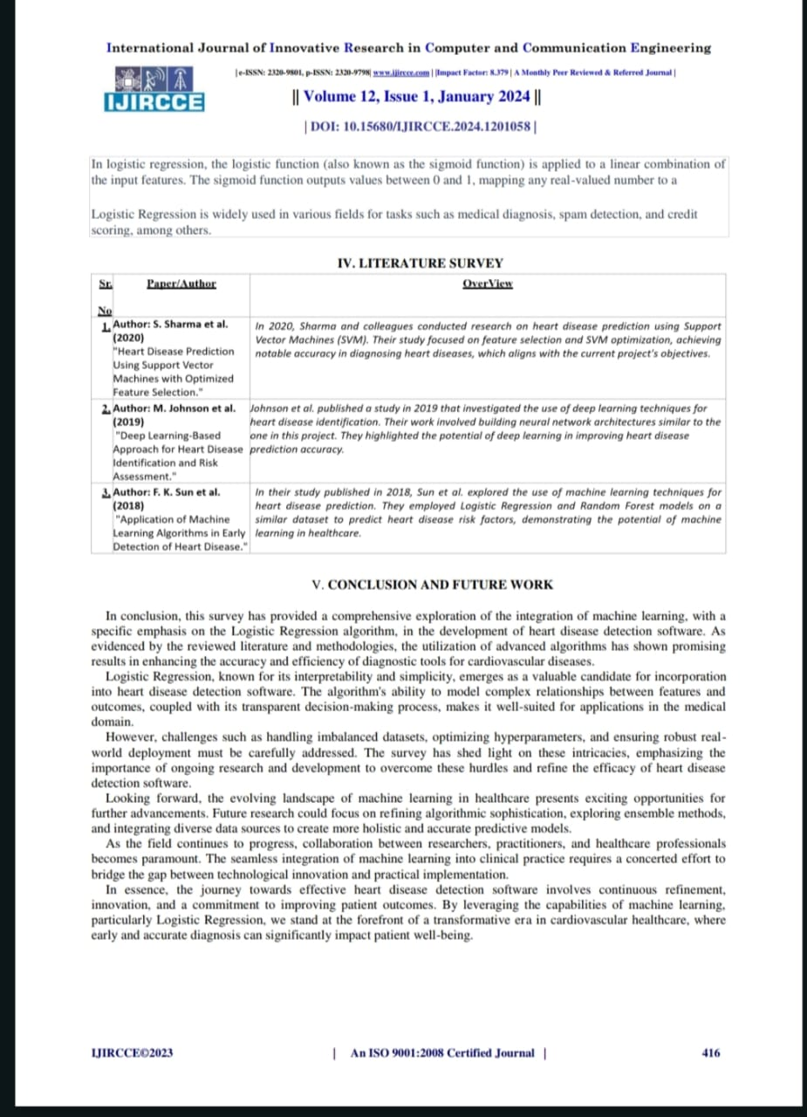

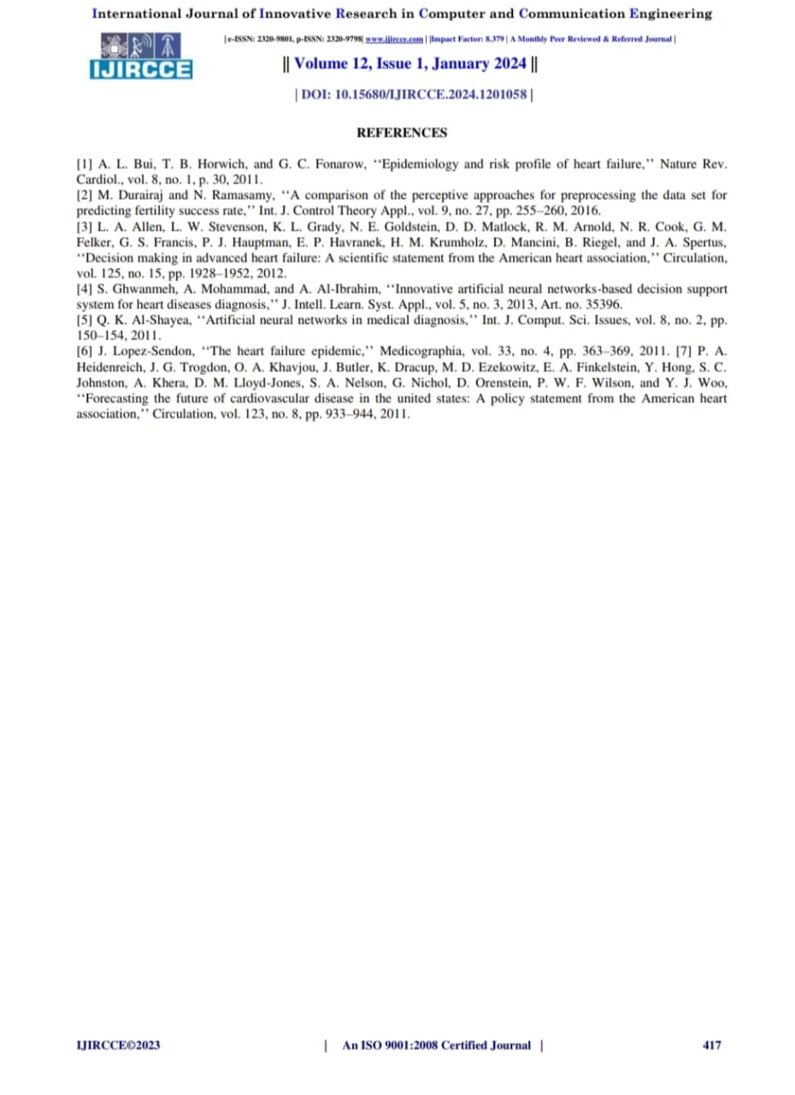



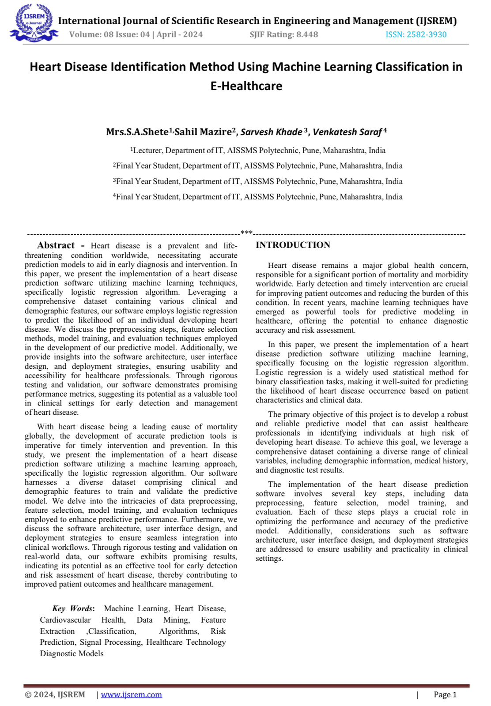

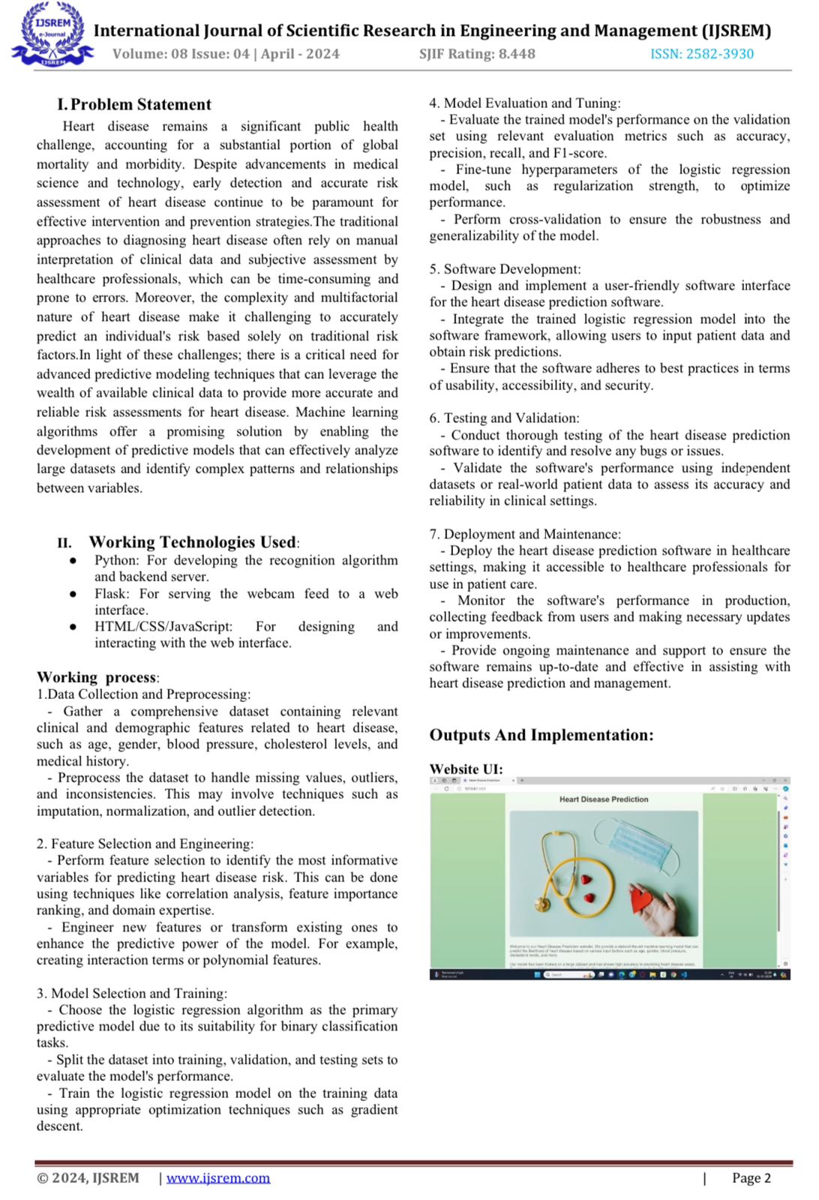
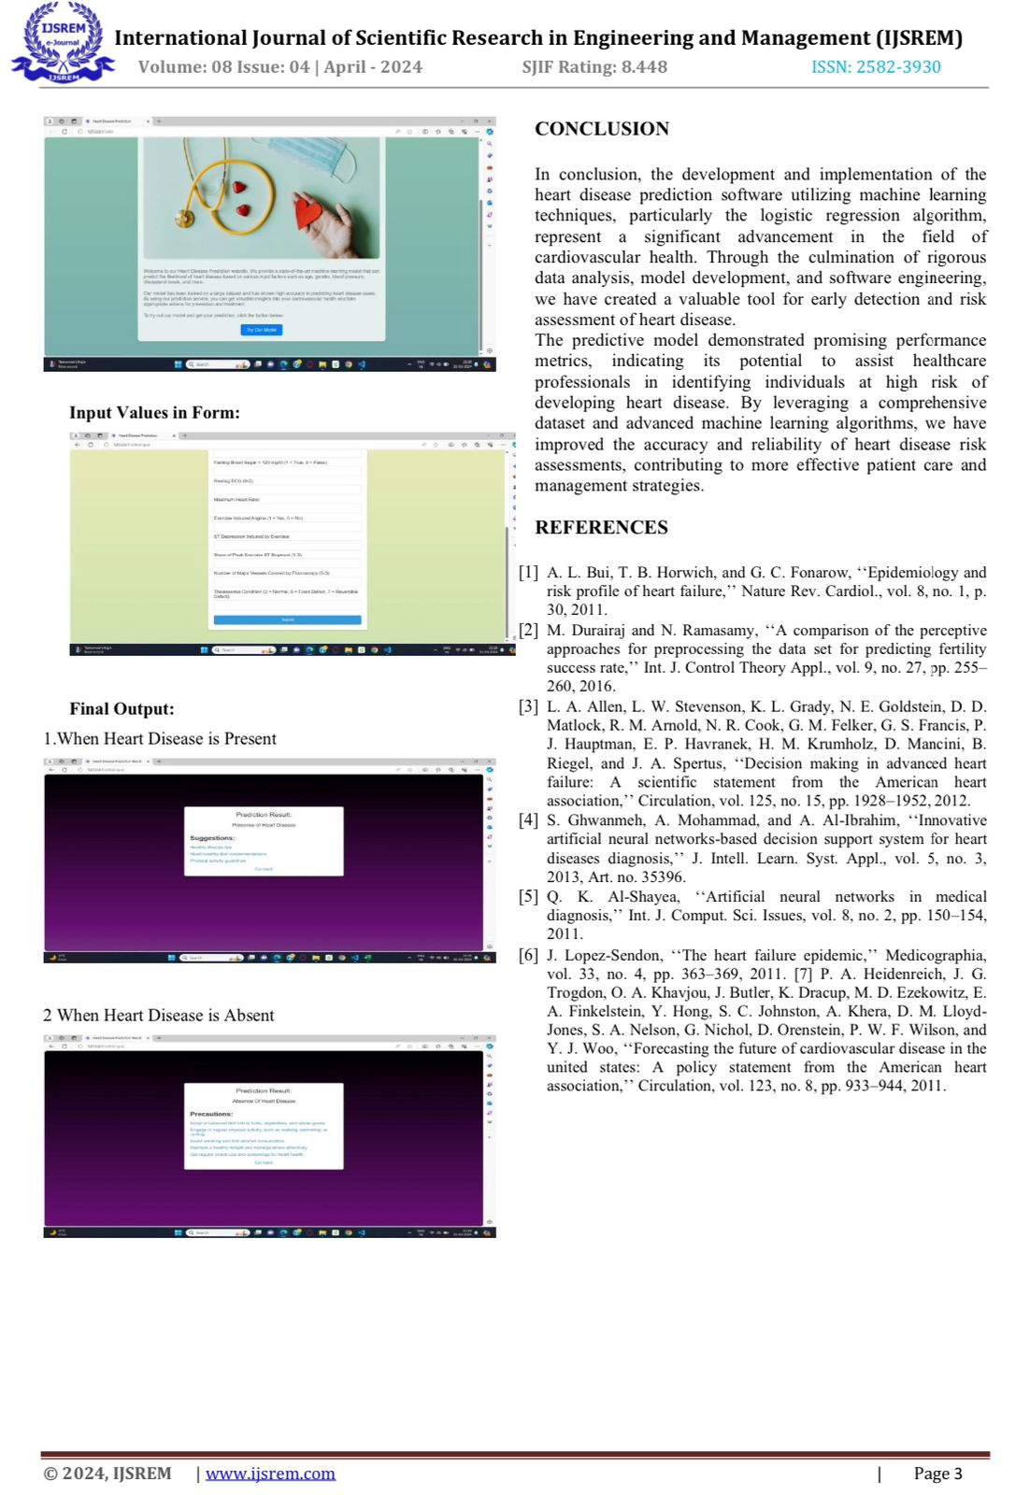

Base paper Certificates:




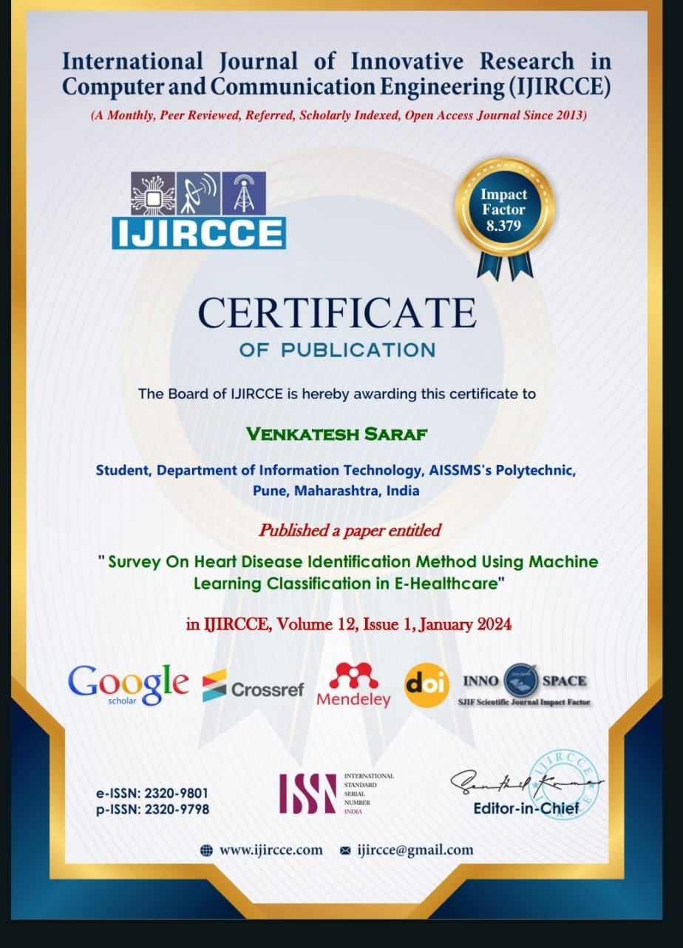

Implementation Paper Certificates:







CHAPTER 9
APPENDIX B EVAULATION SHEET

PROGRESSIVE ASSESSMENT (PA) OF CAPSTONE PROJECT –
EXECUTION AND REPORT WRITING
Evaluation Sheet for Internal Assessment
Name of Student: Sarvesh khade Enrolment No. : 2101410320
Name of Program: INFORMATION TECHNOLOGY Semester: Sixth
Course Title: Capstone Project Execution and report writing Course Code: 22060
Title of Capstone Project: “Heart Disease Identification Method Using Machine Learning Classification in E-Healthcare”
- POs addressed by the Capstone Project:
a. Discipline knowledge
b. Engineering Tools
c. The engineer and society
d. Ethics
e. Individual and team work
f. Communication

- COs addressed by the Capstone Project:
C22060.a: Implement the planned activity individually and/or as team.
C22060.b: Select, Collect and use required information/knowledge to solve the problem.
C22060.c: Use HTML formatting tags to present content on web page.
C22060.d: Develop web pages using images, colors and backgrounds.
C22060.e: Design HTML forms using table and frames.
C22060.f: Create interactive web pages using program flow control structure.
C22060.g: Assess the impact of the project on society.
C22060.h: Create event based web forms using Java script.
C22060.i: Describe machine learning and data concepts tools.
- Other Learning Outcomes achieved through this project:
1. Unit Outcomes (Cognitive Domain)
la. Identify the given Variables, Keywords and constants in C.
1c. Install the given Arduino IDE and editor.
2b. Use different types of operators for writing the arithmetic expressions
2c. Write a "C" program using decision making structure for two-way
branching to solve the given problem..
2d. Write a 'C' program using decision making structure for multi-way branching to solve the given problem.
4a. Use the C standard functions for the given problem.
4b. Develop relevant user defined functions for the given problem using C code.
4c. Write Python module for the given problem
5a. Create classes and objects to solve the given problem.
6d. Handle the given exceptions through C program.
2. Practical Outcomes (in Psychomotor Domain)
1: Install and configure Arduino IDE.
4: Write Simple C Program to demonstrate the use of conditional Statements.
- ‘if’ Statement.
- ‘if…else’ Statement.
- Nested ‘if’ Statement.
5: Write C program to demonstrate use of looping statements:
- while' loop
- for loop
10: a. Write C program to demonstrate math built-in functions
13: Write Python program to demonstrate use of:
- Built-in packages (e.g. NumPy, Pandas).
16: Write a program in C to handle user defined exception for given problem3.
Affective Domain Outcomes
a. Follow safety practices
b. Demonstrate working as a leader/a team member.
c. Maintain tools and equipment.
d. Follow ethical practices.

Sr.No. | Criteria | Max Marks | Marks Obtained
1 | Project Proposal / Identification | 10
2 | Punctuality and overall contribution | 10
3 | Project Diary | 10
4 | Execution of Plan during sixth semester | 20
5 | Project Report including documentation | 15
6 | Presentation | 05
 | Total | 50

Mrs. R. B .Gurav
Signature

PROGRESSIVE ASSESSMENT (PA) OF CAPSTONE PROJECT –
EXECUTION AND REPORT WRITING
Evaluation Sheet for Internal Assessment
Name of Student: Sahil Mazire Enrolment No. : 2101410335
Name of Program: INFORMATION TECHNOLOGY Semester: Sixth
Course Title: Capstone Project Execution and report writing Course Code: 22060
Title of Capstone Project: “Heart Disease Identification Method Using Machine Learning Classification in E-Healthcare”
- POs addressed by the Capstone Project:
a. Discipline knowledge
b. Engineering Tools
c. The engineer and society
d. Ethics
e. Individual and team work
f. Communication

- COs addressed by the Capstone Project:
C22060.a: Implement the planned activity individually and/or as team.
C22060.b: Select, Collect and use required information/knowledge to solve the problem.
C22060.c: Use HTML formatting tags to present content on web page.
C22060.d: Develop web pages using images, colors and backgrounds.
C22060.e: Design HTML forms using table and frames.
C22060.f: Create interactive web pages using program flow control structure.
C22060.g: Assess the impact of the project on society.
C22060.h: Create event based web forms using Java script.
C22060.i: Describe machine learning and data concepts tools.
- Other Learning Outcomes achieved through this project:
1. Unit Outcomes (Cognitive Domain)
1a. Identify the given Variables, Keywords and constants in C.
1c. Install the given C IDE and editor.
2b. Use different types of operators for writing the arithmetic expressions
2c. Write a ‘C’ program using decision making structure for two-way
branching to solve the given problem..
2d.Write a 'C' program using decision making structure for multi-way branching to solve the given problem.
4a. Use the C standard functions for the given problem.
4b. Develop relevant user defined functions for the given problem using C code.
4c. Write C module for the given problem
5a. Create classes and objects to solve the given problem.
6d. Handle the given exceptions through C program.
2. Practical Outcomes (in Psychomotor Domain)
1: Install and configure Arduino IDE.
4: Write Simple C Program to demonstrate the use of conditional Statements.
- ‘if’ Statement.
- ‘if…else’ Statement.
- Nested ‘if’ Statement.
5: Write C program to demonstrate use of looping statements:
- while' loop
- for loop
10 )a. Write C program to demonstrate math built-in functions
13:Write Python program to demonstrate use of:
- built-in packages (e.g. NumPy, Pandas).
16: Write a program in C to handle user defined exception for given problem3.
Affective Domain Outcomes
a. Follow safety practices
b. Demonstrate working as a leader/a team member.
c. Maintain tools and equipment.
d. Follow ethical practices.

Sr.No. | Criteria | Max Marks | Marks Obtained
1 | Project Proposal / Identification | 10
2 | Punctuality and overall contribution | 10
3 | Project Diary | 10
4 | Execution of Plan during sixth semester | 20
5 | Project Report including documentation | 15
6 | Presentation | 05
 | Total | 50

Mrs. R. B. Gurav
Signature

PROGRESSIVE ASSESSMENT (PA) OF CAPSTONE PROJECT –
EXECUTION AND REPORT WRITING
Evaluation Sheet for Internal Assessment
Name of Student: Venkatesh Saraf Enrolment No. : 2101410351
Name of Program: INFORMATION TECHNOLOGY Semester: Sixth
Course Title: Capstone Project Execution and report writing Course Code: 22060
Title of Capstone Project: “Heart Disease Identification Method Using Machine Learning Classification in E-Healthcare”
- POs addressed by the Capstone Project:
a. Discipline knowledge
b. Engineering Tools
c. The engineer and society
d. Ethics
e. Individual and team work
f. Communication

- COs addressed by the Capstone Project:
C22060.a: Implement the planned activity individually and/or as team.
C22060.b: Select, Collect and use required information/knowledge to solve the problem.
C22060.c: Use HTML formatting tags to present content on web page.
C22060.d: Develop web pages using images, colors and backgrounds.
C22060.e: Design HTML forms using table and frames.
C22060.f: Create interactive web pages using program flow control structure.
C22060.g: Assess the impact of the project on society.
C22060.h: Create event based web forms using Java script.
C22060.i: Describe machine learning and data concepts tools.
- Other Learning Outcomes achieved through this project:
1. Unit Outcomes (Cognitive Domain)
la. Identify the given Variables, Keywords and constants in C.
1c. Install the given Arduino IDE and editor.
2b. Use different types of operators for writing the arithmetic expressions
2c. Write a 'C" program using decision making structure for two-way
branching to solve the given problem..
2d. Write a 'C' program using decision making structure for multi-way branching to solve the given problem.
4a. Use the C standard functions for the given problem.
4b. Develop relevant user defined functions for the given problem using C code.
4c. Write C module for the given problem
5a. Create classes and objects to solve the given problem.
6d. Handle the given exceptions through C program.
2. Practical Outcomes (in Psychomotor Domain)
1: Install and configure Arduino IDE.
4: Write Simple C Program to demonstrate the use of conditional Statements.
- ‘if’ Statement.
- ‘if…else’ Statement.
- Nested ‘if’ Statement.
5: Write C program to demonstrate use of looping statements:
- while' loop
- for loop
10 )a. Write C program to demonstrate math built-in functions
13:Write Python program to demonstrate use of:
- built-in packages (e.g. NumPy, Pandas).
16: Write a program in C to handle user defined exception for given problem3.
Affective Domain Outcomes
a. Follow safety practices
b. Demonstrate working as a leader/a team member.
c. Maintain tools and equipment.
d. Follow ethical practices.
Sr. No. | Criteria | Max Marks | Marks Obtained
1 | Project Proposal / Identification | 10
2 | Punctuality and overall contribution | 10
3 | Project Diary | 10
4 | Execution of Plan during sixth semester | 20
5 | Project Report including documentation | 15
6 | Presentation | 05
 | Total | 50

Mrs. R. B. Gurav
Signature

CHAPTER 10
REFERENCES & BIBLIOGRAPHY

REFERENCES AND BIBLIOGRAPHY

- A. Abdullah, S. A. Enazi and I. Damaj, "AgriSys: A smart and ubiquitous controlled-environment agriculture system," 2016 3rd MEC International Conference on Big Data and Smart City (ICBC), Muscat, 2016, pp. 1-6.
- A. Gheith, R. Rajamony, P. Bohrer, K. Agarwal, M. Kistler, B. L.
W. Eagle, C. A. Hambridge, J. B. Carter, and T. Kaplinger, IbmBluemix mobile cloud services, IBM Journal of Research and Development, vol. 60, no. 2-3, pp. 7:17:12, March 2016.
- A. Lage and J. C. Correa, Weather station with cellular communication network, in 2015 XVI Workshop on Information Processing and Control (RPIC), Oct 2015, pp. 15.
- A.V. Bosisio and M. P. Cadeddu, Rain detection from ground- based radiometric measurements: Validation against rain sensor observations, in 2015 IEEEInternational Geo-science and Remote Sensing Symposium (IGARSS), July 2015, pp. 23232326.
- Arduino Available: http://www.arduino.cc/download/
- Goldstein, A., Fink, L., Meitin, A., Bohadana, S., Lutenberg, O., Ravid, G., 2017. Applying machine learning on sensor data for irrigation recommendations: revealing the agronomists tacit knowledge. Precis. Agric. 19, 421
444.https://doi.org/10.1007/s11119-017-9527-4.
- G. M. Salim, H. Ismail, N. Debnath, and A. Nadya, Optimal light power consumption using LDR sensor, in 2015 IEEE International Symposium on Robotics and Intelligent Sensors (IRIS), Oct 2015, pp. 144148.
- H. Saini, A. Thakur, S. Ahuja, N. Sabharwal, and N.Kumar, Arduino based automatic wireless weather station with remote graphical application and alerts, in 2016 3rd International Conference on Signal Processing and Integrated Networks (SPIN), Feb 2016, pp. 605609.
- I. Corporation, Ibm-blue-mix [Online] Available: https:// www.ibm.com/cloud- computing/bluemix/
- Jaguey, J.G., Villa-Medina, J.F., Lopez-Guzman, A., Porta-Gandara, M.A., 2015.Smartphone irrigation sensor. IEEE Sens. J. 15, 5122 5127.https://doi.org/10.1109/JSEN. 2015.2435516.
- Mean Squared Error [WWW Document], 2018. Tutor vista (accessed 8.29.18). https://math.tutorvista.com/statistics/ mean- squared-error.html.
- M.H. Asghar, A.Negi, and N. Mohammadzadeh, Principle application and vision in internet of things (IoT), in International Conference on Computing, Communication Automation, May 2015, pp. 427431.
- N. Putjaika, S. Phase, A. Chen-Im, P. Phunchongharn and K. Akkarajitsakul, "A control system in an intelligent farming by using arduino technology," 2016 Fifth ICT International Student Paper Conference (ICT-ISPC), NakhonPathom, 2016, pp. 53-56.

